Workplace Campaign Pledge Form

MY CONTACT INFORMATION
First Name:___________________________________ Last Name:_______________________________________

Home Address____________________________________________________________________________________

City:____________________________________________ State:_____________________ Zip Code_____________

Email:_____________________________________________________________________________________________

Work Phone:__________________________________ Cell Phone:________________________________________

WORKPLACE
Employeer:________________________________________________________________________________________

PLEDGE INFORMATION
I am making a PAYROLL DEDUCATION PLEDGE
I pledge $_____________________________ per #___________________ of pay periods.
My payroll pledge total is $________________________________________ (Pledge amount X #Pay Periods)
I am mailing a CHECK in the amount of $_____________________________________
mail check to United Way of Pitt County 226 West 8th St. Greenville, NC 27858

INVEST YOUR PLEDGE
Please select how your donation is to be invested. A minimum donation of $50 is required when designating to an organization other than United Way of Pitt County. The organization must hold the federal designation of 501(c)3.
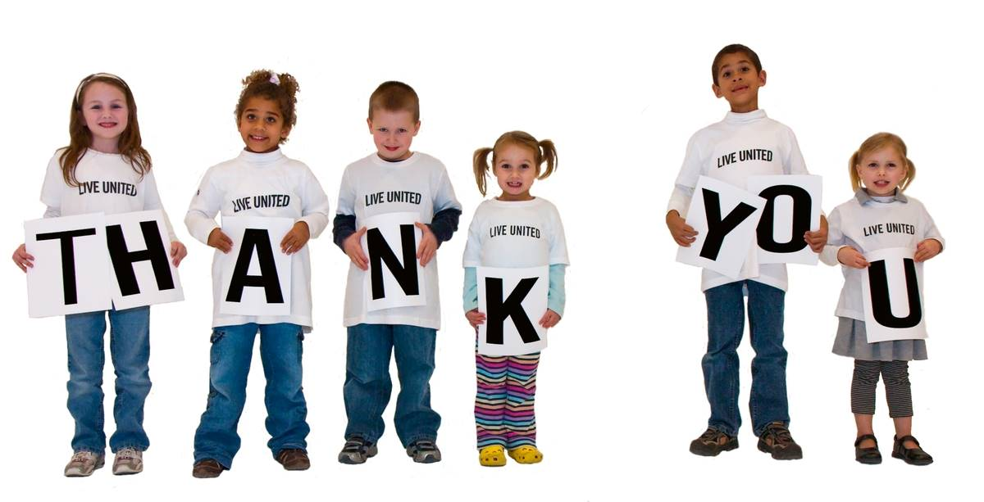
Invest my pledge:
United Way of Pitt County
Other United Way
Other 501(c)3 Organization
Name of other United Way or 501(c)3 organization:________________________________________________
Address of 501 (c) 3 organization:_____________________________________________________________
Return form to your employee campaign manager or as directed by your workplace.

